H&T BILL

- Generate H&T Bill

- The H&T Bill is a manual type of bill.
- The Generated Bill for payment shall be visible in the “Update payment against bill” section.
- The H&T bill shall be integrated with Tally.

Warehouse personnel can generate a new H&T bill or update the existing one by following steps:

Accounts and Billing Billing H & T Bill

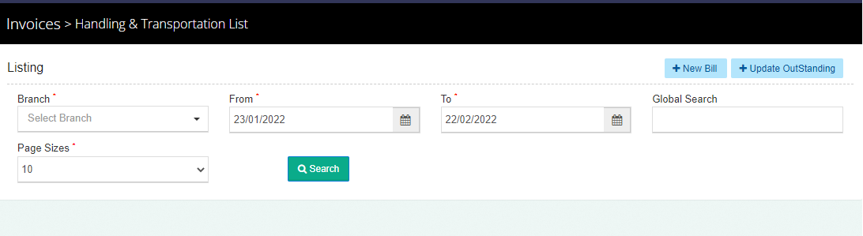

- Search
  - The user will be able to search for a particular “H&T bill” by clicking on the search button.
  - The user can enter the below-mentioned information:
    - Branch
    - From Date
    - To Date
    - The user can also perform a global search to scale down the search.
  - By clicking on the search button the results will get auto-populated based on the search performed.

- Listing
  - The user will be able to view the list of H&T invoices generated by the user.
  - Clicking on the print icon will redirect the user to the print screen.

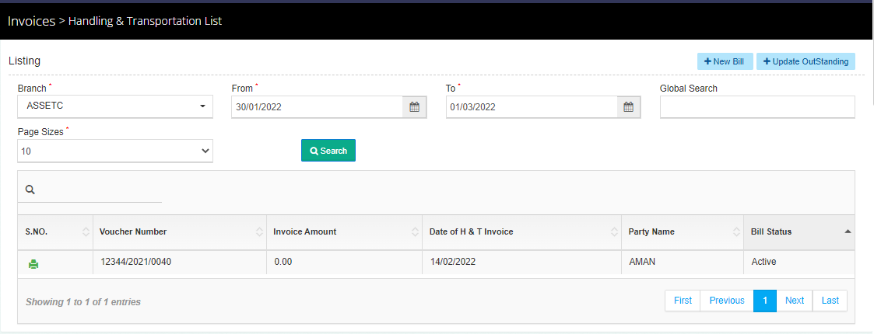

- New Bill
  - Clicking on the new bill button will redirect the user to the new bill creation screen.

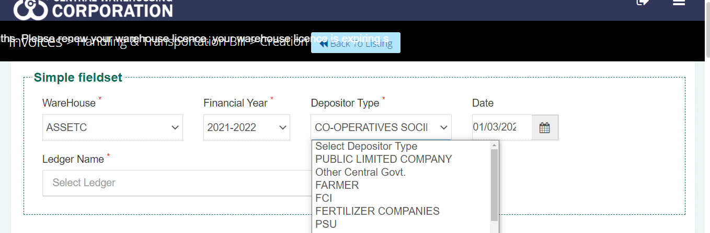
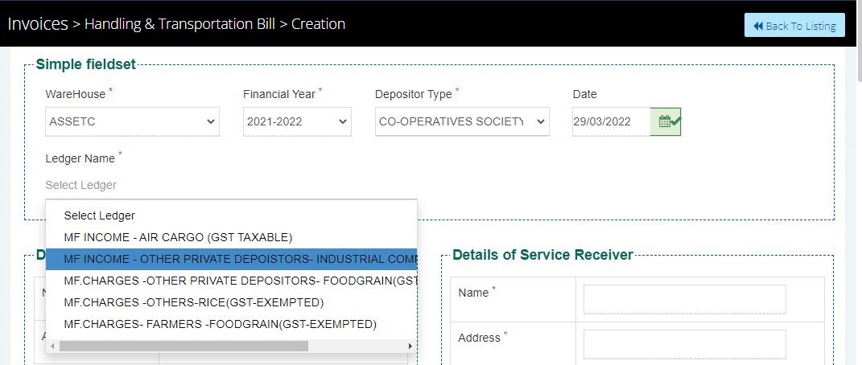

  - WHM can create a new bill by selecting the below-mentioned particulars:
    - Warehouse
      - This will be auto-populated.
    - Financial Year
      - This field will carry the current financial year and is non-editable.
    - Date
      - Current date by default and is editable.
    - Ledger Name
- If the ledger name selected is GST taxable, then the user has to select Yes or No for SEZ.
- If the user selects Yes for SEZ, then he has to select SEZ undertaking No. and also SEZ payment type.

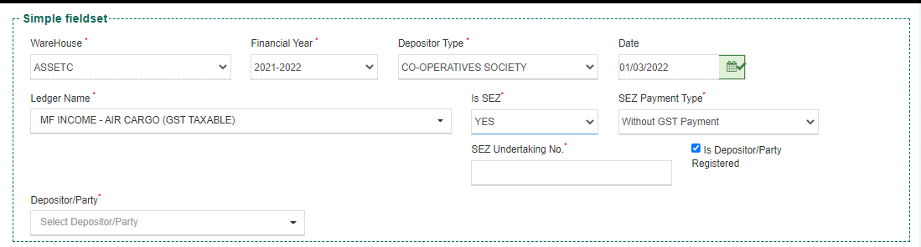
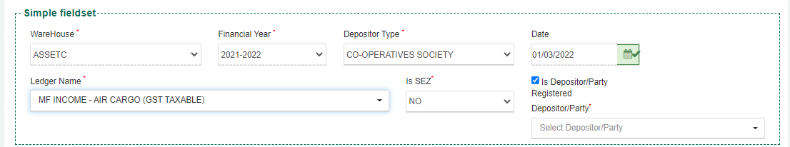

    - Is Depositor/Party registered
      - Checkbox to determine if the receiving party is registered or not.
    - Depositor/Party
      - If the party/depositor is registered: Drop-down to select the party name.
      - If the party/depositor is not registered: an input field to enter the name manually.
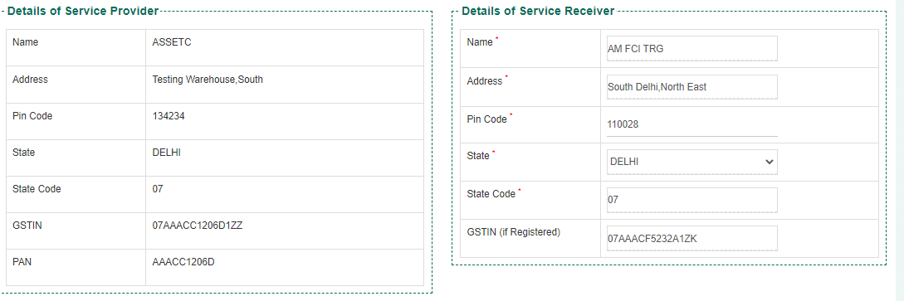

  - The user will be required to enter the details in the service receiver section in case of a non-registered party. Else, details in the service receiver details will be auto-populated.
  - The details of the Service provider are auto-filled.
  - If the state column for service provider and service receiver holds the same name, then the tax applicable will be CGST & SGST. Else, the tax applicable will be IGST.

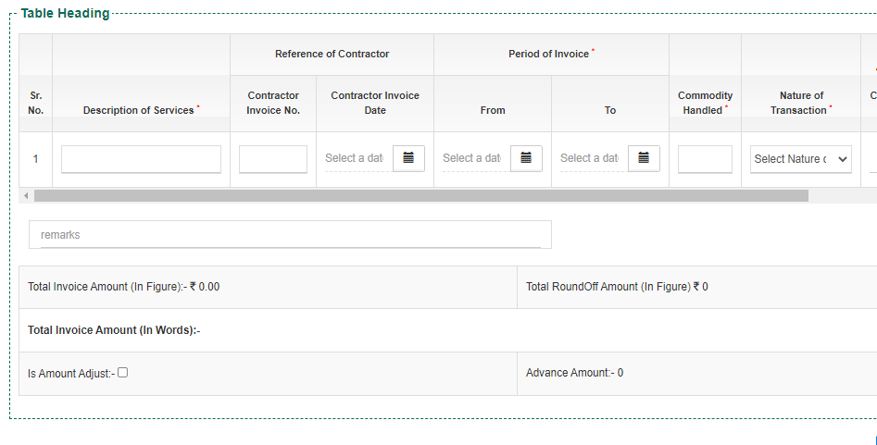
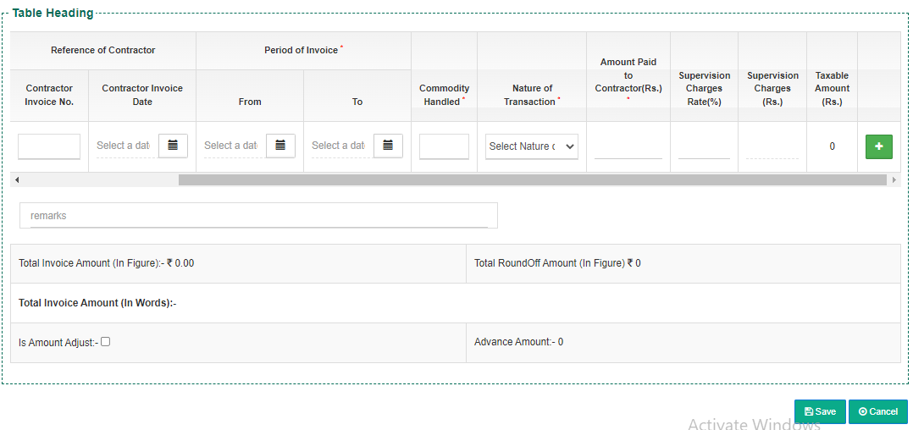
  - The user will be required to enter details in the heading table as depicted in the image above.
    - Description of services
    - Reference of contract
- Contract invoice No.
- Contract invoice Date
    - Period of invoice
- From date
- To date
    - Commodity handled

    - Nature of transaction
    - Amount paid to contractor
    - Supervision charges rate (%)
    - Supervision Charges (Rs.)
    - Taxable Amount
  - The total value will be auto-calculated by the system.
  - The user can view the “Total Invoice Amount” and “Total Round off Amount” of the bill.
  - The user will have the provision to adjust the bill amount with the advance amount by checking the “Is Amount Adjusted” checkbox.
    - If the amount adjusted is greater than the bill generated then, the bill generated will be marked as paid and the corresponding entry will be visible in the adjustment book.
    - If the advance amount is less than the invoice amount then, the outstanding will be visible under the “Update Payment against bill” section.
    - If no amount is adjusted then, no deduction to the total amount will be made.
  - In case the bill amount is adjusted against the advance amount, a Cash Receipt will be generated.
  - Clicking on the “Save” button will generate the bill and exit the screen.

- Update Outstanding
  - The user will be able to generate an outstanding “H&T bill” by clicking on the update outstanding button available.
  - The user will be redirected to the bill creation page where he will be able to enter or update all the required information.

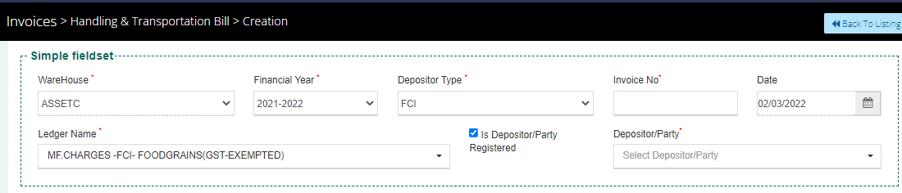
  - The user will be able to enter/select the below-mentioned fields
    - Warehouse
    - Financial Year
- The warehouse name and financial year are auto-populated.
    - Invoice number
      - Invoice number of any past bill for which the outstanding bill is being created.
    - Ledger name
    - Is Depositor/Party registered checkbox
    - Depositor/Party
  - If the depositor/party is registered then, the details in the service receiver will get auto-populated with the information stored. Else, the information will be entered manually by the user.
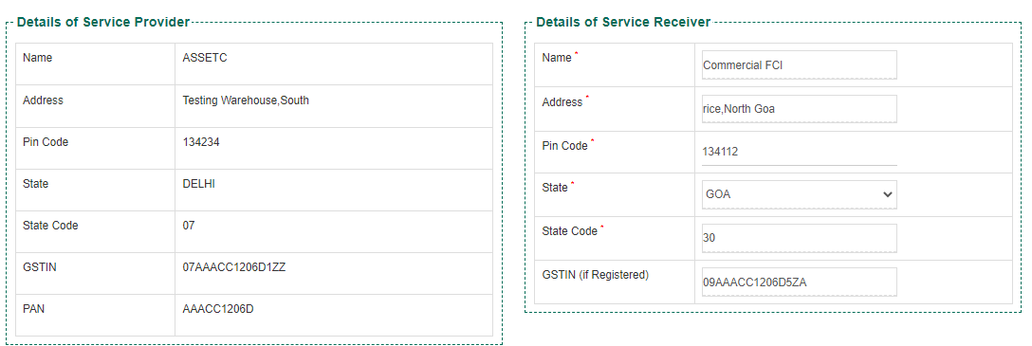

  - The user will be able to enter the details in the table heading section listing the required fields to generate the outstanding bill. the details that need to be entered are:
    - Description of services
    - Reference of contract
- Contract invoice No.
- Contract invoice Date
    - Period of invoice
- From date
- To date
    - Commodity handled

    - Nature of transaction
    - Amount paid to contractor
    - Supervision charges rate (%)
    - Supervision Charges (Rs.)
    - Taxable Amount

  - The user will be able to adjust the bill with the advance amount received from the respective depositor by checking the “Is Amount Adjust” checkbox.
  - Clicking on the “Save” button will generate the outstanding bill and exit the screen.

